Hagan’s Formula Sheets – If Carlsberg did formula sheets…
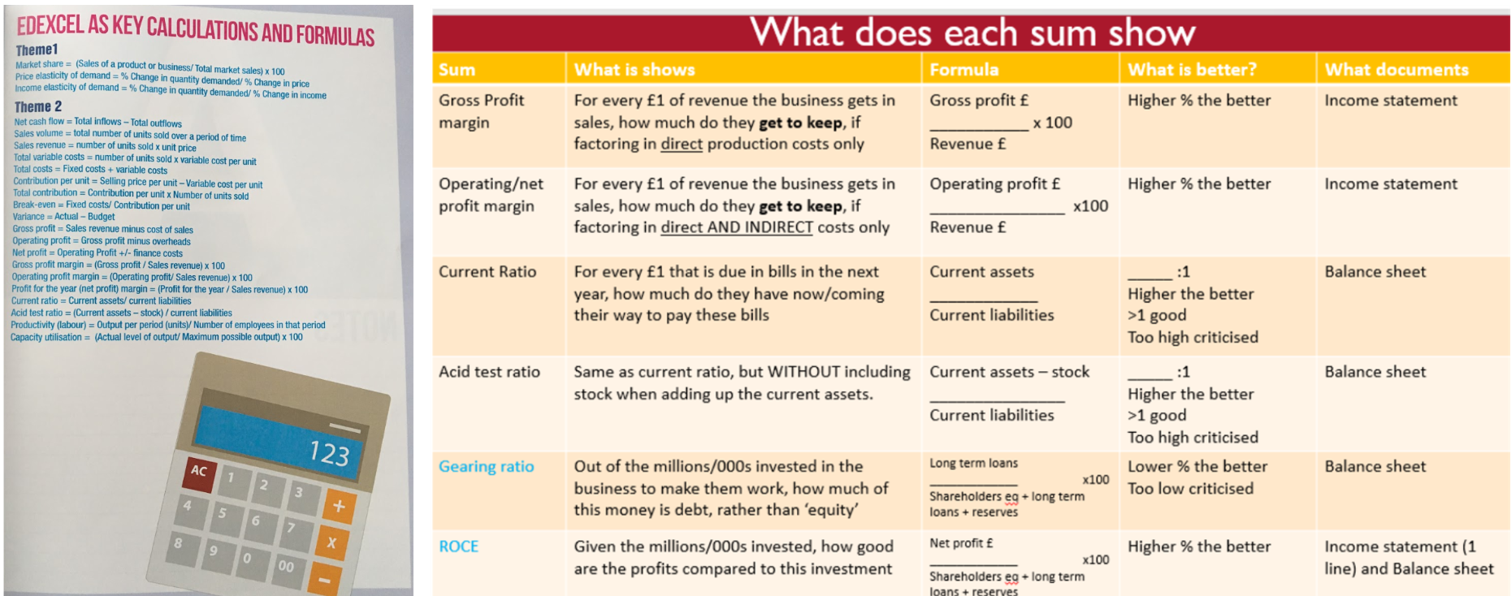
Hagan’s key ways to improve liquidity ratios: 1] Sell FA 2] New long term loan 3] Issue new shares. All have downsides. Others do count technically
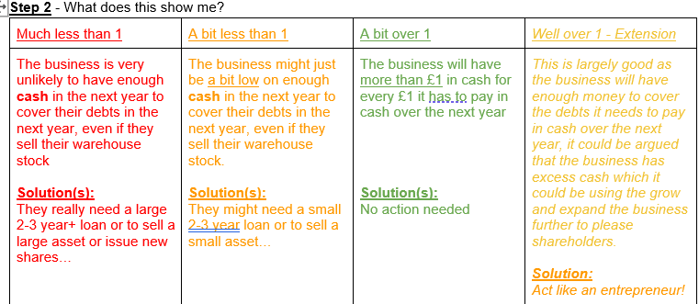
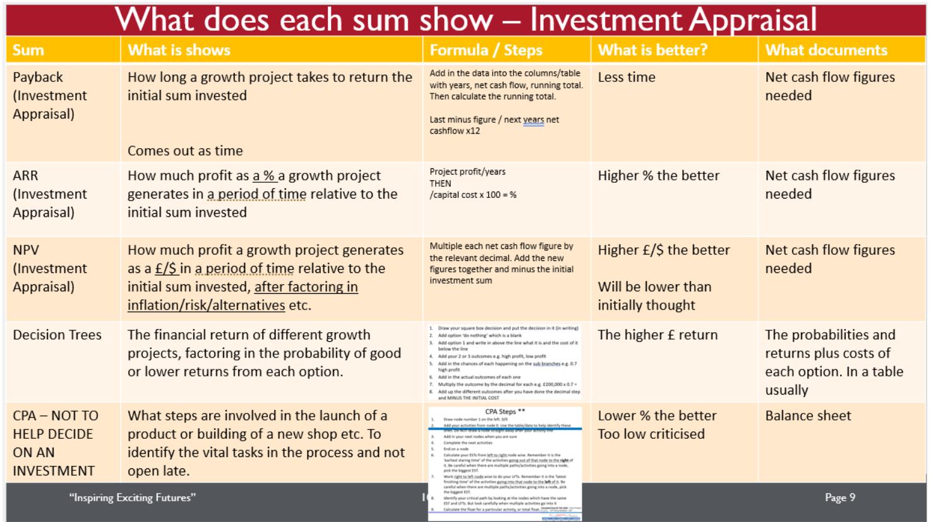
Note: Hagan’s simpler ARR formula is above. It assumes you did the proper tables as recommended.
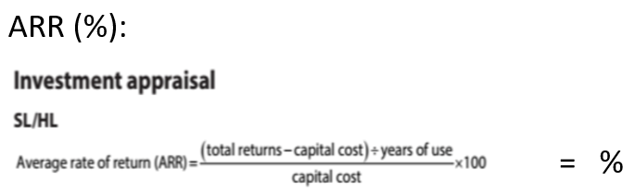
More detail on Investment Appraisal
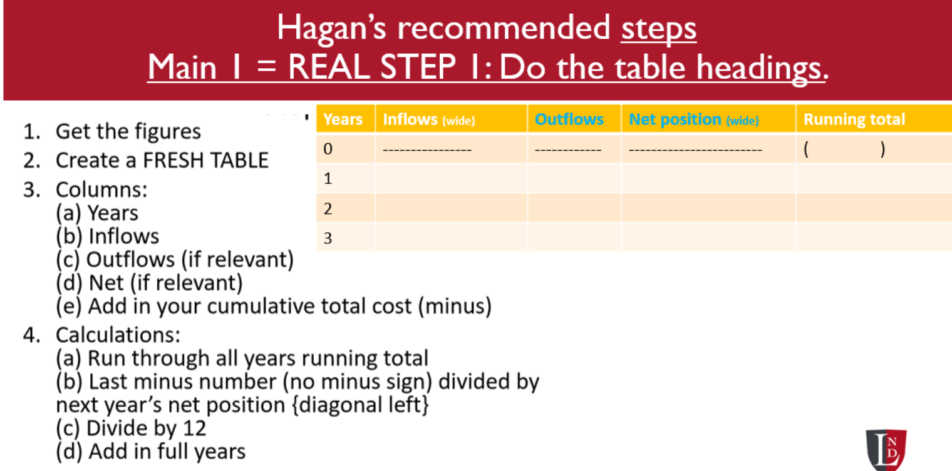 | 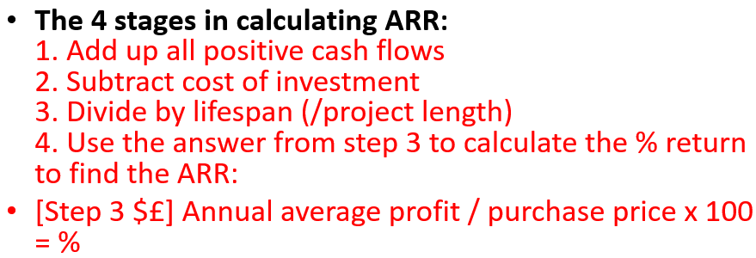
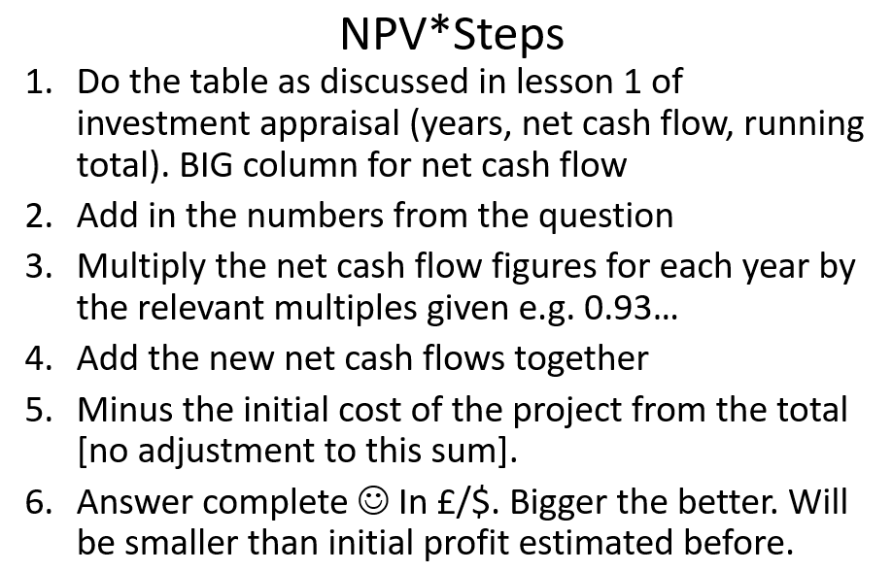 | Decision Trees [not same topic as Invest Appr]  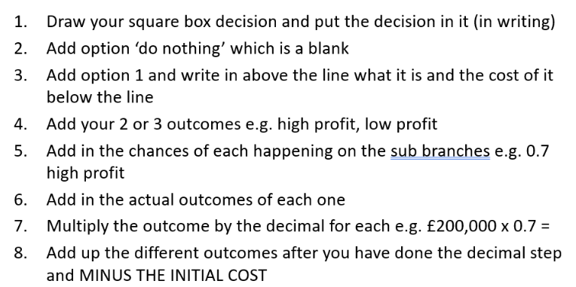

More theme 3 maths steps
